NetFlix project with MYSQL database

1. Create netflix project , Create 2 applications : movie and webseries and open project in vs code

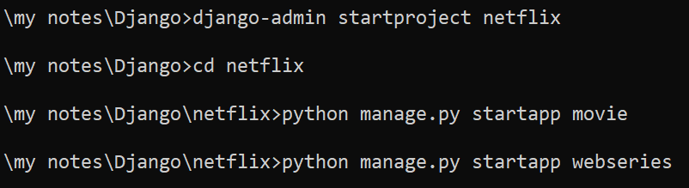

1. Register applications in settings.py

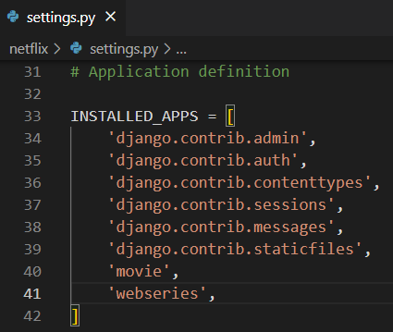

1. Working with mysql database
   1. Be ready with database name, username and password
   2. Here I am using default username and password of mysql i.e root and root
   3. Create new database for our project in workbench

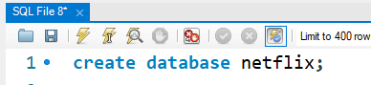

* 1. In setting.py register above database with user credentials

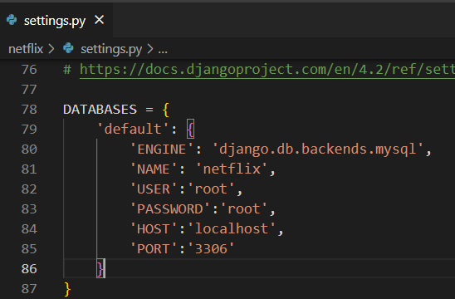

* 1. Install mysqlclient library
  2. Runserver : open terminal in vs code and run : >python manage.py runserver
  3. Open new terminal on vs code and check for django to mysql connetion by running following command
  4. 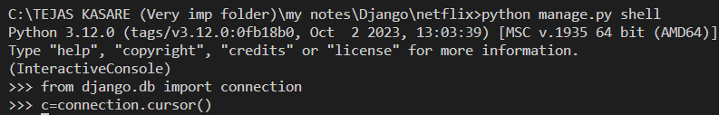

4. Create model class in models.py

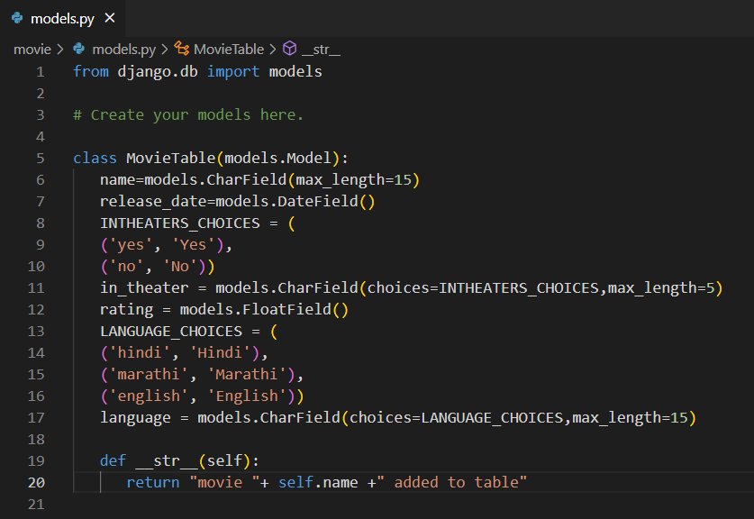

5. Register model class in admin.py

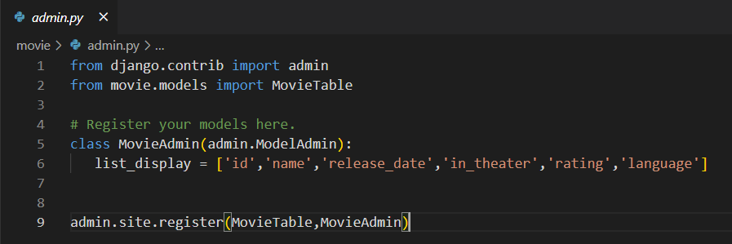

6. Makemigrations and migrate

>python manage.py makemigrations

>python manage.py migrate

7. check tables in flipkart database

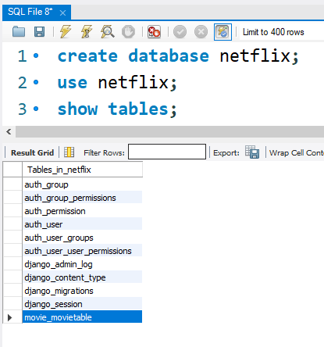

8. View structure of movie_movietable table

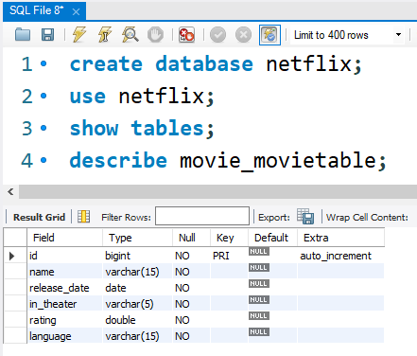

9. DONE !!!!!!!!!!!!!!!

10. Creating superuser to access admin panel

>python manage.py createsuperuser

I have created with credentials : tejas, admin@123

11. Open admin panel by : *http://127.0.0.1:8000/admin* and add above credentials

12. You will get movie table

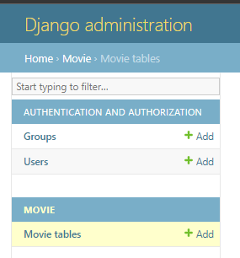

13. Add some data in movie table

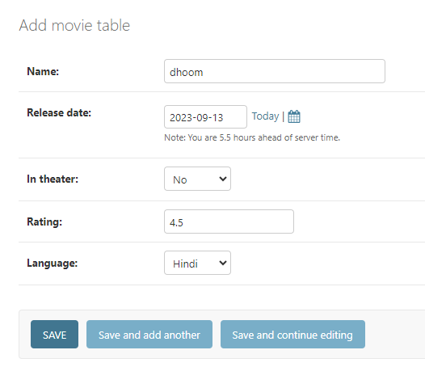

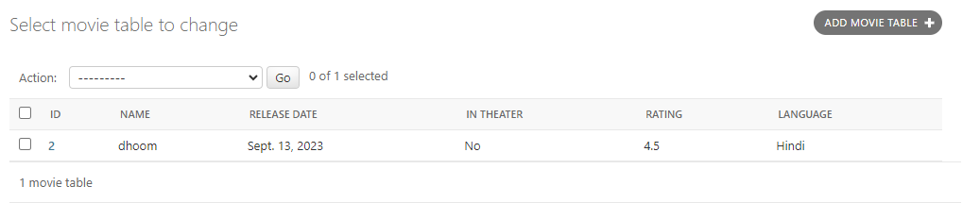

14. Check in mysql

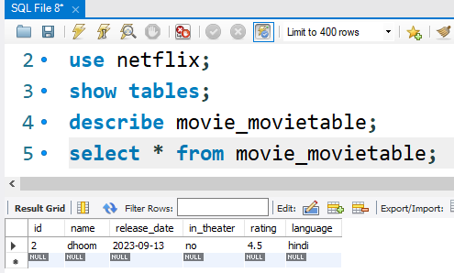

15. DONE !!!!!!!!!!!!!!!!!

16. Displaying products into HTML page

1. Create templates folder -> register templates folder in settings.py

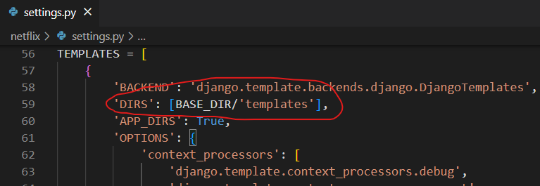

1. create movie folder inside templates folder -> create view_movies.html in movie folder

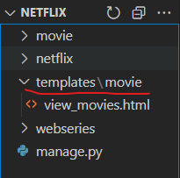

1. create view to fetch all data from model
   1. movie -> views.py

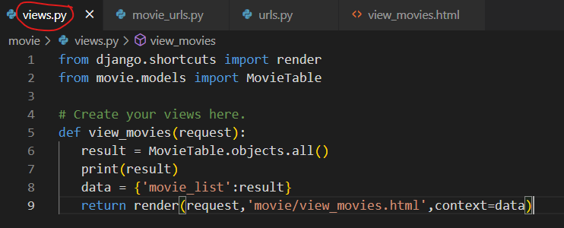

1. create application level url for above view
   1. create movie_urls.py in movie folder

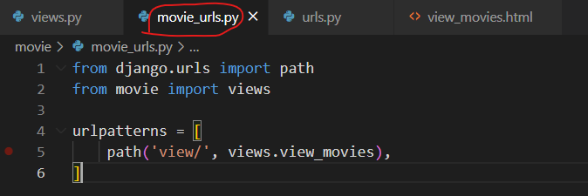

1. register above application level url in project level url : urls.py

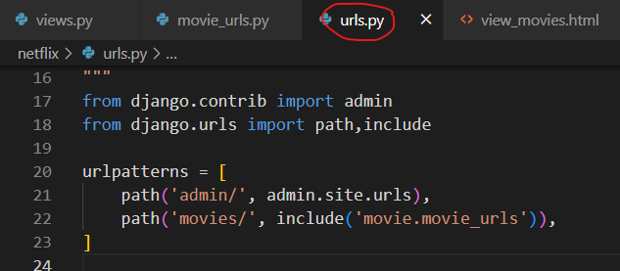

1. create table in view_movies.html to show all records

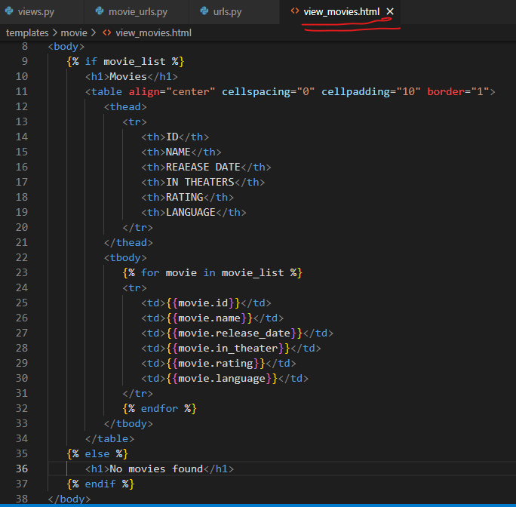

1. check for output

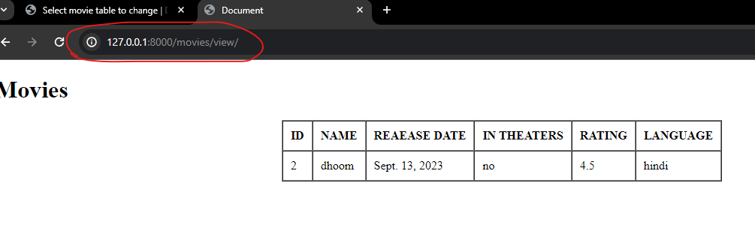

1. DONE !!!!!!!!!!!!!!!!!!!!!!!!!!!!!!!!!!!!!!!!!!!!!!!!!!!!!!

CREATING A FORM TO ADD MOVIES

There are 2 types of forms available in django : django form and model form

Lets understand how to create form using django form

1. Create forms.py in application level (here inside movie folder)

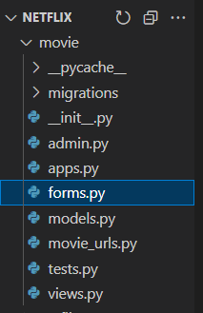

1. Add below code in it

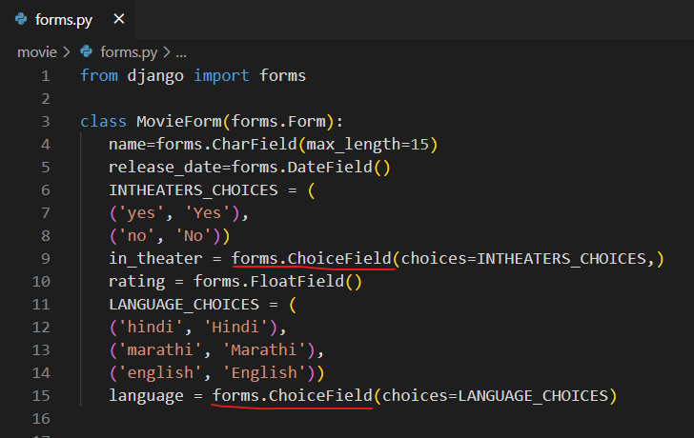

1. Register above form in views.py by create separate view to display form

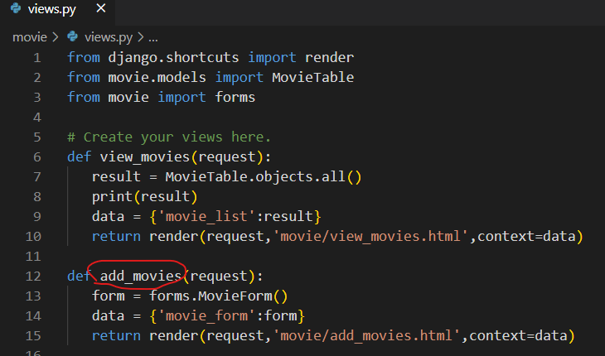

1. Create add_movie.html in templates > movie > add_movies.html

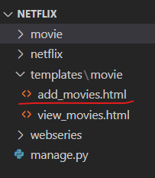

1. Add following code and csrf token to Solve csrf problem

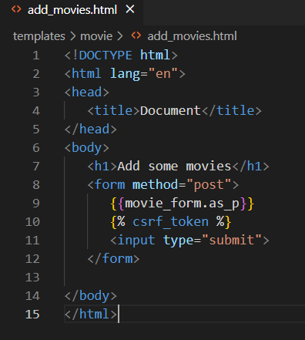

1. Logic to Collect data from form

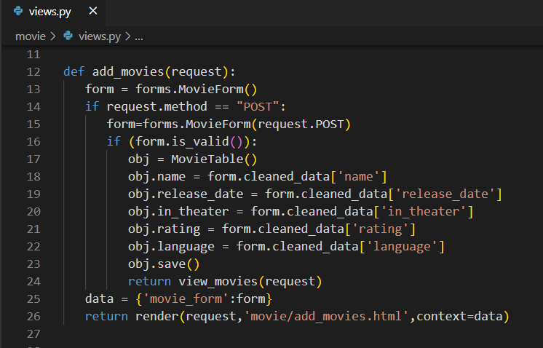

1. Check for output

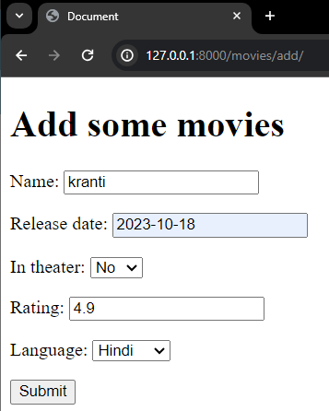

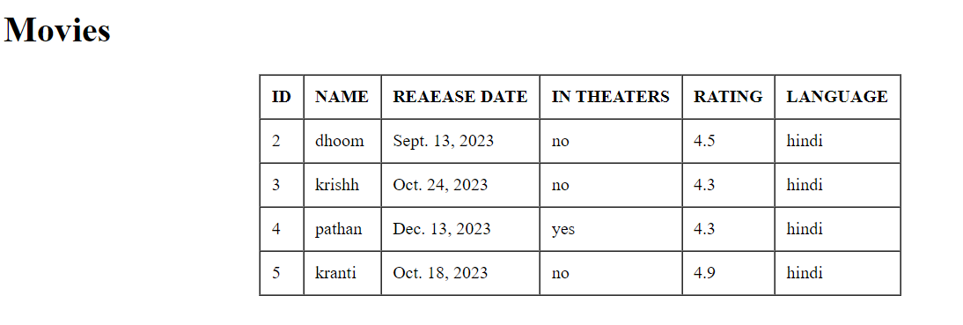

1. DONE !!!!!!!!!!!!!!!!!!!!!!!!!!!!!!